**Excel Assignment – 11**

**Use the below table for the following Questions.**

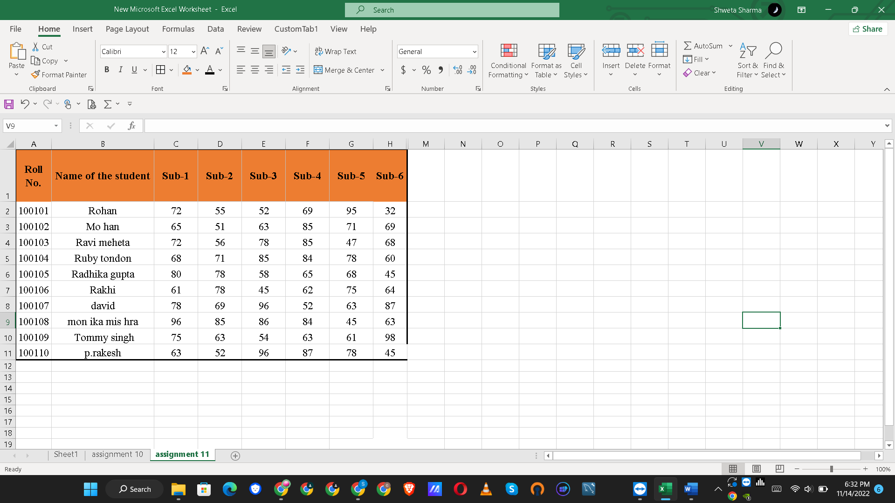

**Q1: Find the Minimum Marks and Maximum marks scored by each student.**

Ans : 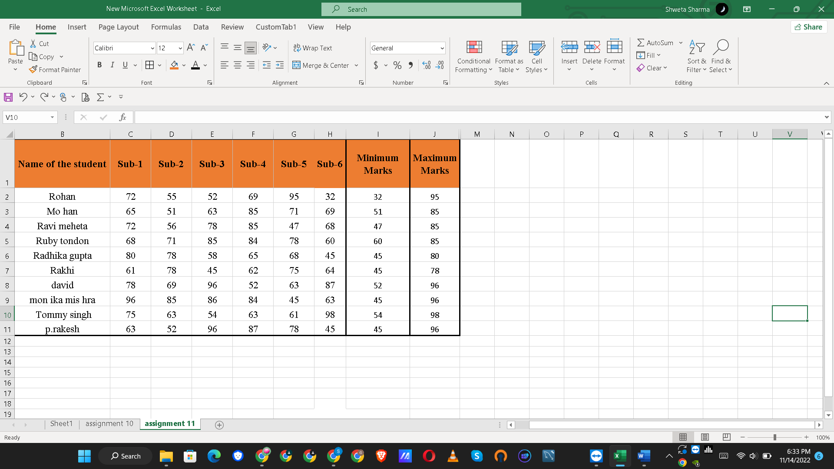

**Q2: Calculate the totals for each student, use conditional formatting to highlight the top students who have scored more than 480.**

Ans:

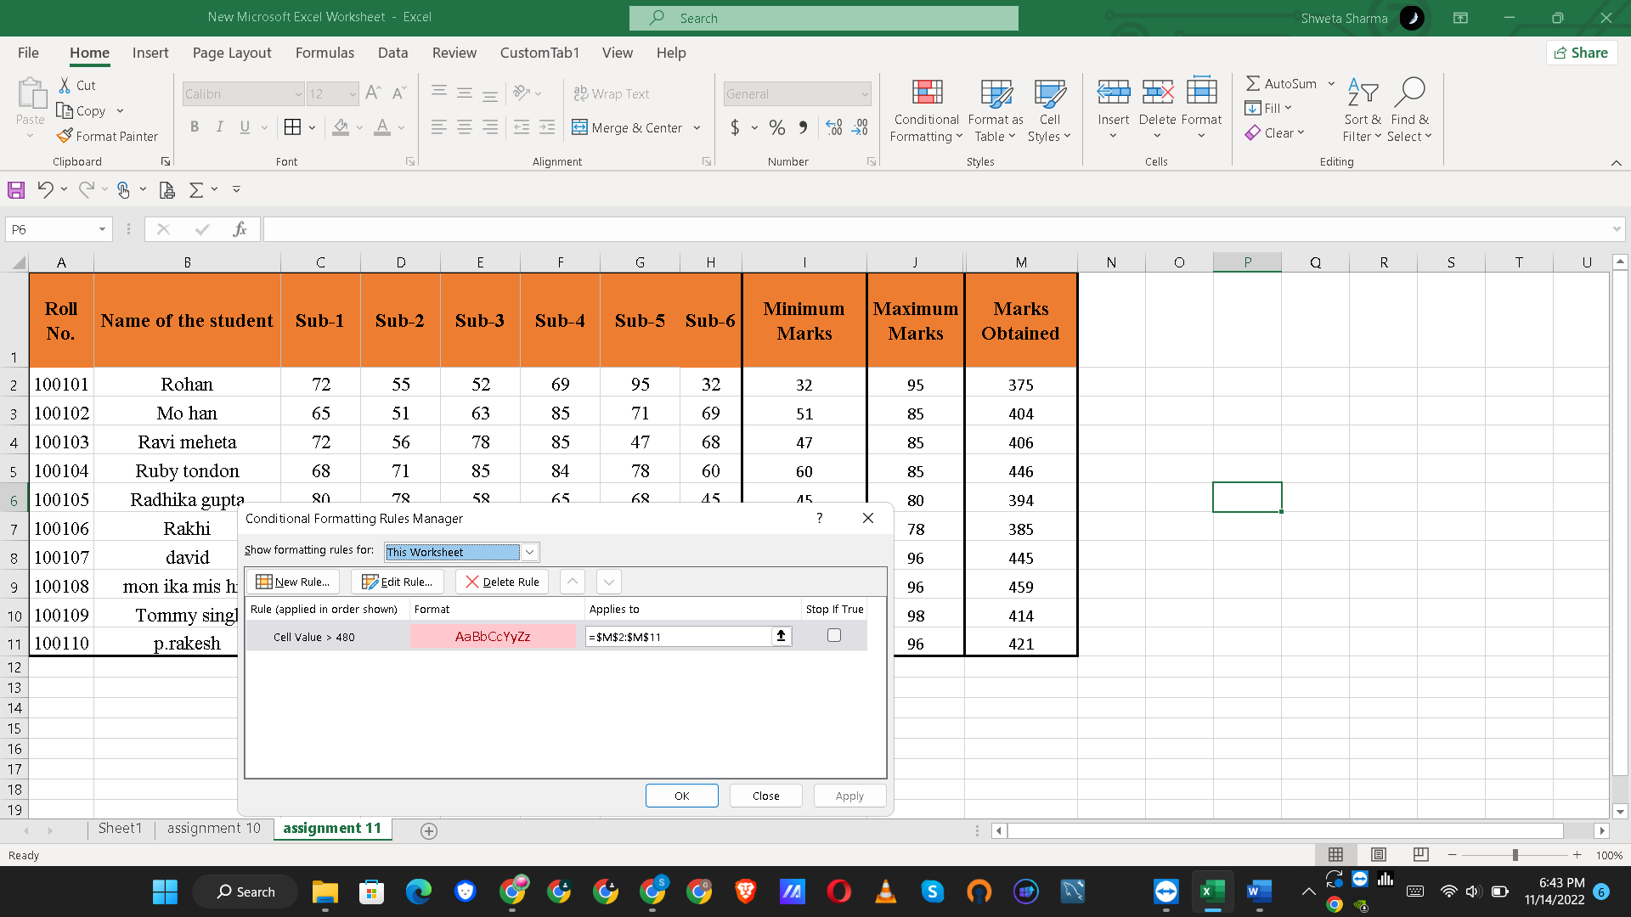

A rule is created where if student get more than 480 total marks then highlight it .But In this student record no one has scored more than 480 marks.

**Q3: Calculate the length of the names of each student.**

Ans: Length of name is calculated by **=Len(cell number)** and drag for all columns

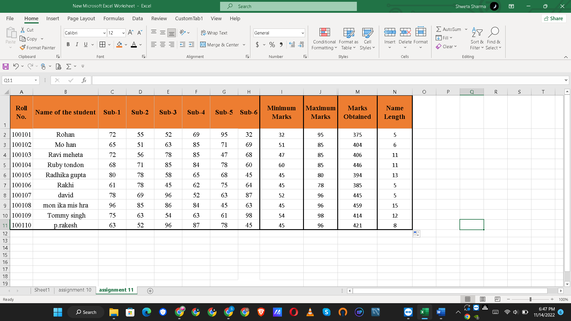

**Q4: Replace the Name Rakhi with Rocky. Use Formulas.**

Ans:

**Q5: Combine the Roll Numbers and Names. Use formulas. The end result should look like below. 100101Rohan**

Ans:

**Q6: As you can see that some names have spacing issues. Use Formulas to correct that spacing. Also ensure that the names and surnames start with a capital letter.**